Contact  Selsdon Community Centre  132 Addington Road  South Croydon, CR2 8LA  Tel: 020 8651 4944  Fax: 020 8657 2268  Email: info@selsdoncontact.org.uk | www.selsdoncontact.org.uk
Contact – Serving the Local Community in So Many Ways
My name is Andy Stranack and on the 1st April I took over as the new manager of Selsdon Contact. I having been involved with Contact for many years as a volunteer and Trustee and it is a real privilege to take over the management role from Janet Jones. Janet has left an amazingly well managed and thriving organisation and has provided excellent advice and support to me during the transition period.
I have received a very warm and friendly welcome from the 300 volunteers that keep Contact running on a day to day basis. The range of services we offer the local community is wide and varied and includes providing practical help, advice, support and information to people living in our area.
We provide transport for medical appointments, do shopping/prescription collection, visiting/befriending, give carer support, issue loan equipment, and we run a shopping bus scheme. Not so many are aware that we also arrange monthly coffee mornings and regular outings and day trips.
We are supported and funded by the local Churches in Selsdon and by Croydon Council. We are always interested in getting feedback and ideas from our clients and volunteers.
If you are interested in any of our services, have some spare time to volunteer, or just want to pop in to say hello. We can be found on the lower ground floor of the Selsdon Community Centre (below Sainsbury’s) and are open Monday to Friday 10am-3pm.
I’m not sure that I will beat Janet’s record of 24 years as manager of Contact !!! But I look forward to meeting many of you over the next few years as we continue to provide community services to residents living in the local area.

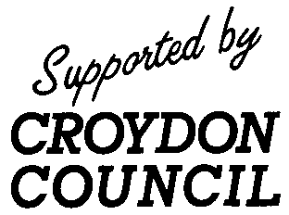
Contact: ChurchesNeighbourhood Care Registered Charity 1124346
Company limited by guarantee Registered in England. No. 6582829

